November 2019 Taylor Community Library
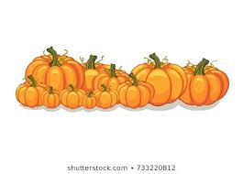
Sunday | Monday | Tuesday | Wednesday | Thursday | Friday | Saturday
Holiday Gift Basket Raffle Visit the Taylor Community Library to purchase raffle tickets for our Holiday Gift Baskets. Baskets being raffled are: Friends Central Perk LEGO, Disney Princess Activities, Paw Patrol Game and Merchandise and Disney My Colors Board Book Set. Raffle tickets are 2/$1.00; 12/$5.00; 25/$10.00. Drawing will be held on December 18. |  |  |  |  | 1 | 2
 |  |  |  |  |  | Look for circles day
3 | 4 | 5 | 6 | 7 | 8 | 9
National Sandwich Day  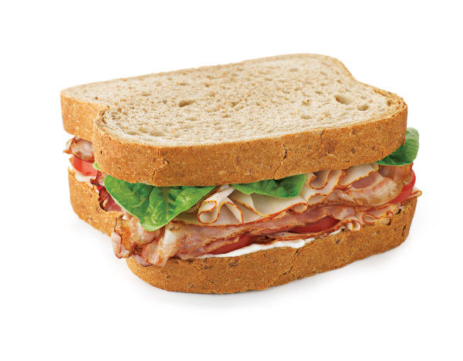 | New to Medicare  9:30 am-2:30 pm by appt. | Election Day  Library is Closed | Crochet Workshop 1:00 pm  Chernobyl The Mini Series  6:30 pm Ep. 1 & 2  NEPA Writers 6:30 pm | Toddler Storytime 10:30 am  Polish Language Class 4:00 pm  Chicklits Book Club 6:30 pm | New to Medicare  9:30 am-2:30 pm by appt. | Teen Snack & Chat  11:30 am – 12:00pm  Read to the Cats  1:00 pm – 2:00 pm  Snowman Candle Teen Craft 1:00 pm
10 | 11 | 12 | 13 | 14 | 15 | 16
 | Veteran’s Day  Library Closed | Dark Shadows 6:00 pm  School Age Fun Time  6:30 pm - 7:30 pm | Crochet Workshop 1:00 pm  Chills ‘n Frills Book Club 1:00 pm  Chernobyl – The Mini Series Ep. 3 & 4 | Toddler Storytime 10:30 am  Polish Language Class  4:00 pm | America Recycles Day | Hallmark Movie Christmas Countdown  11:00 am- 2:00 pm
17 | 18  Free Movie Matinee “Late Night” 12:30  Read to the Dogs  6:30 p.m | 19  School Age Fun Time  6:30 pm - 7:30 pm  Teen Reading Lounge  3:00 pm | 20  Crochet Workshop 1:00 pm  Chernobyl – The Mini Series Ep. 5 | 21  Toddler Storytime 10:30 am | 22  New to Medicare  9:30 am-2:30 pm by appt.  Elder Law Clinic  12:30 pm-3:30 pm | 23  Suicide Prevention Training & Discussion  11:00 am
24 | 25 | 26 | 27 | 28 | 29 | 30
Celebrate Your Unique Talent Day | 1949 "Rudolph, the Red-Nosed Reindeer" appeared on music charts. It was originally an advertising jingle.  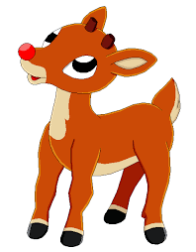 | School Age Fun Time  6:30 pm - 7:30 pm | Crochet Workshop  1:00 pm  Library closing at  3:00 pm today. | Library Closed Today  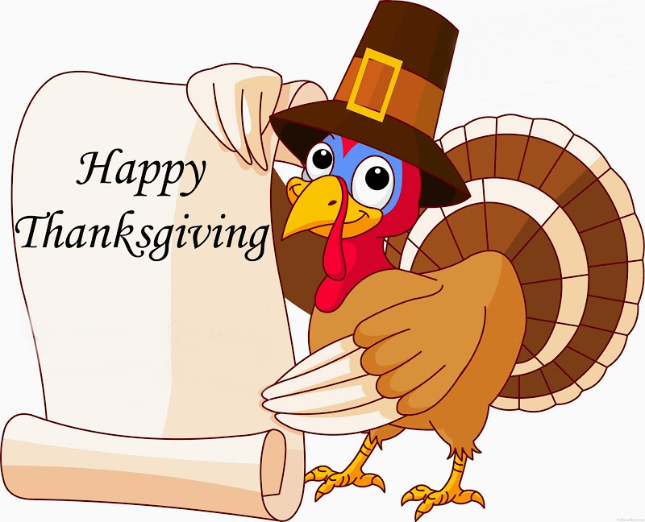 | Library Closed Today | Library is open regular hours 9:00 am – 4:00 pm
Coming in December - 6:00 p.m. – 8:30 p.m. Christmas Pet Photos with Santa Paws. Bring your pet to visit Santa Paws. Take your own photo for $5.00 or $10.00 for (1) 5x7 photo mailed to you via Shutterfly. All proceeds benefit Pawsitively for the Animals.

